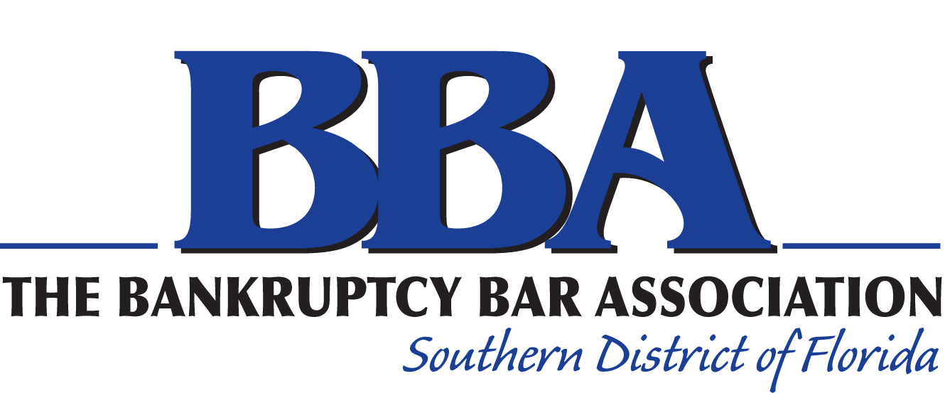 | BBASDFL’s Scholars Program- 2023 Application Form

Applicant Information
Full Name: |  |  |  | Date:
 | Last | First | M.I.

Address:
 | Street Address | Apartment/Unit #

 | City | State | ZIP Code

Phone: |  | Email

Projected Graduation Year:
Law School:

Enclosures (check next to each item):

Resume
Law School Transcript
One (1) academic or professional reference letter
Personal Statement

Plans After Law School Graduation:

Do you intend on taking the Florida Bar? | YES | NO

Do you intend on practicing bankruptcy law in South Florida? | YES | NO

Certification and Signature
I, ____________________________________, certify that my answers and information given in this application and supporting documents is complete and accurate and provided for the purpose of the BBA’s consideration for the BBA’s Scholars Program. I understand that the information provided is subject to investigation by the BBA, its members, and staff for the purpose of selecting scholarship recipients. This includes, without limitation, contacting supervisors, law professors, references, or judges relevant to my professional and academic background. I understand that any false, misleading, inaccurate statements or incomplete information may serve as basis for denial of my Scholarship award. I further understand that the requirement to provide truthful, accurate, and complete information is a continuing obligation that requires me to notify the BBA, through writing, of any material changes to the responses to this application.
If selected, I commit to attend all required BBA Scholars events, including the BBA Annual Retreat.
Signature: |  | Date:

